


ARTICLE TITLE AND AUTHOR INFORMATION

Author order
International Journal Polytechnic applies a double-blind peer review process. Manuscripts submitted for review MUST NOT contain any author names, affiliations, or contact details.
All author information must be provided exclusively through the mail
ijp@politehnika.edu.rs
Affiliations
Authors are responsible for ensuring the accuracy and completeness of metadata, including author order, affiliations, institutional email addresses, and corresponding author designation. Affiliations must follow the format: University, Faculty, Department, City, Country, email address and an ORCID ID.
The corresponding author must be clearly indicated. Incomplete or inconsistent metadata may delay editorial processing.

- Manuscript Preparation and Formatting
Manuscripts must be prepared using this International Journal Polytechnic template and predefined styles in the word processor. The header section of the template is managed by the Editorial Team and should not be modified.
  - Abstract
The abstract must be informative and self-contained, summarizing the topic, scope, methodology, key results, and conclusions. It should be 150–250 words, written in complete sentences, in the past tense, using active voice and third-person perspective. Abbreviations must be defined at first use. Citations are not allowed.
  - Keywords
Provide 3–6 keywords that do not appear in the title, using defined terms from the Web of Science, immediately after the abstract.
  - Highlights
Highlights must consist of 3–4 bullet points that:
    - present novel results and/or methods
    - increase discoverability via search engines
    - are concise (maximum 150 characters per bullet)
  - Nomenclature
Define all symbols, abbreviations, and units that are not part of standard SI conventions.
- Manuscript Structure
A standard manuscript must include the following sections:
- INTRODUCTION – research context, objectives, relevance
- MATERIALS AND METHODS – experimental or analytical procedures
- RESULTS – presentation of findings
- DISCUSSION – interpretation and comparison of results with literature
- CONCLUSIONS – key outcomes without repeating the abstract
- ACKNOWLEDGEMENT - funding and contributions (or ‘’no external funding was received’’)
- REFERENCES - formatted as specified below
All non-applicable sections must explicitly state this; they must not be omitted.

- Formatting Requirements
  - Tables
Tables must be editable (Word format only; images not accepted). Tables must be numbered consecutively with Arabic numerals in order of appearance in the text (Table 1, Table 2, …) and include descriptive titles. Units must be provided in square brackets (e.g., [s]). Avoid duplication of data already presented elsewhere. Tables must be attached as separate files in electronic form. Indicate in the text where the table should be placed (e.g., Table 1 in red letters). Abbreviations must be explained in the footnote below the table, not in the header. If using data from other sources, cite them accordingly.
Table 1. Summary of heading levels and formatting (Table-caption)

Heading level | Example | Font size and style
1st-level heading | 1 Introduction | 10 point, bold, italic, left
2nd-level heading | 2.1 Printing Area | 10 point, bold, italic, left
3rd-level heading | 3.1.1 Run-in Heading in Bold | 10 point, bold, italic, left

  - Figures
Figures and photographs must be numbered consecutively with Arabic numerals in order of appearance in the text (Figure 1, Figure 2, …) and cited in text. Photographs should be with a minimum resolution of 300 dpi, in sufficient size, not less than 6 cm x 8 cm.
Accepted formats: JPEG, PNG; no borders, white background. Figures must be submitted as separate files. Indicate in the text where the figure or photograph should be placed (e.g., Figure 1 in red letters). If the figure or photograph has already been published elsewhere, cite the source.
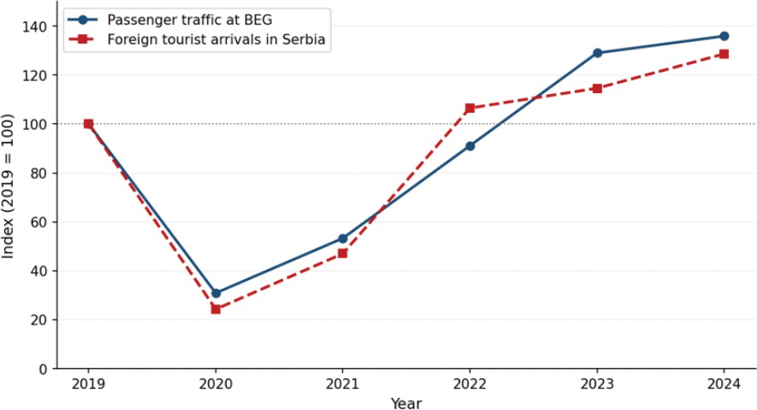
Graphs must be created in Excel; attach the original file with the table from which the graph was constructed. Schemes must be created in CorelDRAW X3 or earlier versions. Mark them with Arabic numerals in order of appearance in the text and specify the name. Indicate in the text where graphs or schemes should be placed (e.g., Graph 1, Scheme 1 in red letters).
Fig. 1. Figure captions must be placed below the corresponding illustrations. Both figures and captions should be centered on the page. (Figure-caption)

  - Equations
Equations must be numbered consecutively in parentheses and aligned according to template rules below - placed in the first column of the two-column table with no borders, with each equation occupying a separate row.
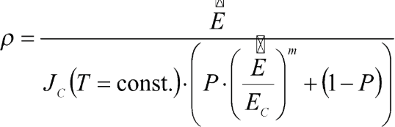
  - Special Notes
The SI system of units must be used consistently. Abbreviations must be written in full at first use, followed by the abbreviation in parentheses. Non-SI symbols and units must be listed in the Nomenclature section.
- Manuscript Submission
Only original manuscripts not published or under review elsewhere will be considered. Each manuscript is peer-reviewed by at least two independent reviewers. Authors must address all reviewer comments.
Manuscripts must be written in clear academic English and be free of grammatical errors. Professional language editing is recommended prior to submission. To avoid delays, authors are encouraged to use professional editing services.
There is no Article Processing Charge (APC) for manuscripts.
The complete manuscript must not exceed 8.000 words for original research articles, review articles, literature reviews, monograph studies, and professional papers, and up to
1.500 words for articles in other categories.
- References
References must be cited in the text using APA style. The reference list must be complete, accurate, and include all necessary bibliographic details. DOI or URL must be provided when available.
Reference Examples
Journal article:
Petrović, M., & Nikolić, S. (2022). Machine learning applications in industrial automation. International Journal Polytechnic, 1(1), 12–24. https://doi.org/10.xxxx/ijp2022-00123 Book:
Jovanović, A. (2019). Fundamentals of biotechnology. Springer Press.
Book chapter:
Milošević, D., & Todorović, B. (2020). Renewable energy systems in smart grids. In R. Stević & N. Marković (Eds.), Advances in electrical engineering (pp. 145–167). Springer Press.
Conference paper:
Stanković, J., Đorđević, M., & Lazić, P. (2025). IoT-based monitoring in precision agriculture. In Proceedings of the International Conference Polytechnic, Belgrade, Serbia (pp. 78–85). Technical Faculty Press.

Web source:
Ministry of Education, Science and Technological Development of the Republic of Serbia. (2023). Strategy for scientific and technological development. https://www.mpn.gov.rs/strategija

APPENDIX - Template style indicators
To ensure consistent formatting, please apply the following styles:
(Paper-Title) – Used for the main title of the article. (Abstract) – Applied to the abstract text. (Keywords) – Applied to the list of keywords.
(Highlights) – Used for the bulleted highlights section.
(Heading 1) – For main sections (e.g., 1 Introduction, 2 Materials and Methods).
(Heading 2) – For second-level section titles (e.g., 1.1 Section title). (Heading 3) – For third-level subsection titles (e.g., 1.1.1 Subsection title). (Normal) – For all standard paragraphs in the main body.
(List paragraph) – Applied to all bulleted or numbered points.
(Table-caption) – Applied to the titles placed above tables.
(Figure-caption) – Applied to the titles placed below illustrations/figures.
(Equation) – Used for mathematical formulas and equations.
(Reference-item) – Applied to each individual entry in the reference list at the end of the manuscript.

